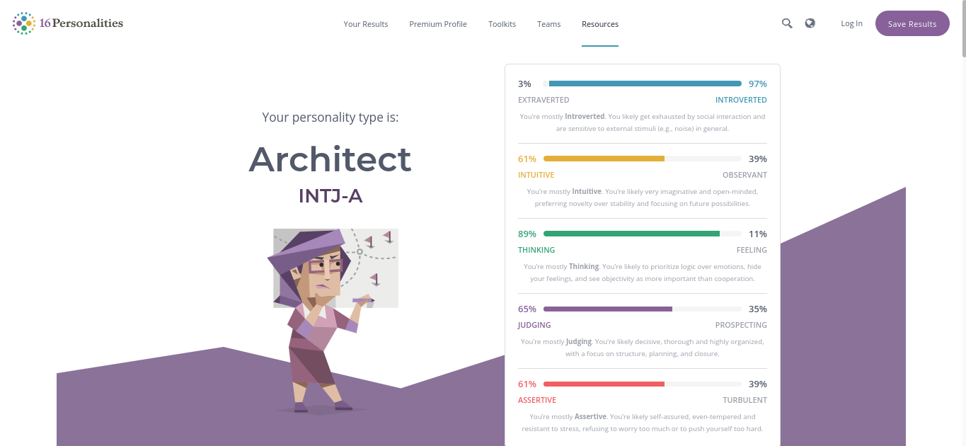

16 Personalities

Your Results

Premium Profile

Toolkits

Teams

Resources

a

Log In

Save Results

3%

97% INTROVERTED

EXTRAVERTED

Your personality type is:

You're mostly Introverted. You likely get exhausted by social interaction and

are sensitive to external stimuli (e.g. noise) in general.

61%

Architect

INTJ-A

39% OBSERVANT

INTUITIVE

You're mostly Intuitive. You're likely very imaginative and open-minded,

preferring novelty over stability and focusing on future possibilities.

89%

11%

THINKING

FEELING

You're mostly Thinking. You're likely to prioritize logic over emotions, hide

your feelings, and see objectivity as more important than cooperation.

65% JUDGING

35% PROSPECTING

You're mostly Judging. You're likely decisive, thorough and highly organized,

with a focus on structure, planning, and closure.

39%

61% ASSERTIVE

TURBULENT

You're mostly Assertive. You're likely self-assured, even-tempered and resistant to stress, refusing to worry too much or to push yourself too hard.